8th Annual
Granville County Senior Services
Holiday Bazaar
Saturday, November 4, 2017
107 Lanier Street
919-693-1930
Email: julie.brockman@granvillecounty.org , diane.williams@granvillecounty.org

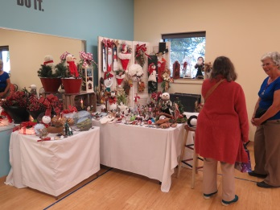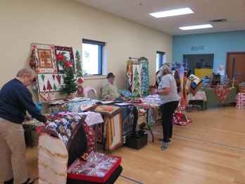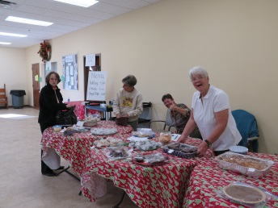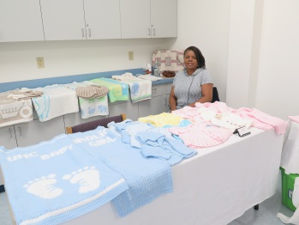
ENTRY FEES (based on location within the center)
- Dining Room - $30 per table (limited space)
- Fitness Room - $25 per table (limited space)
- Art Room and Classroom - $20 per table
All applications and fees are due to Granville County Senior Services by October 20, 2017. Fees can either be paid by check or cash.

INFORMATION
- Priority given to handmade/handcrafted items with a limited number of direct sale vendors. Due to limited space the Senior Center has the right to limit same type items and vendors.
- Each applicant will be notified by email upon acceptance of a space.
- Setup time will be at 8:00 a.m. on Saturday, November 4. The bazaar will run from 9:00 a.m. until 3:00 p.m. All areas are to be packed up by 4:00 p.m. All participants must commit to staying for the entire show.
- A space is defined as: one 6 foot table or two 5’ tables set up in a “L” shape and 2 chairs unless prearranged with Senior Center staff. All tables and locations are on a first-come-first-serve basis.

DATE PAID________

Vendor Application 2017

Name:

Address:

City: State: Zip:

Home Phone #:

Cell Phone #:

Email Address:

Description of items:

Table Set-Up Location
6’_____ Dining Room_____
“L” Shape _____ Fitness Room_____
Own set-up_____ , Art/Class Room_____
description of set-up___________________________

